Recall from geometry

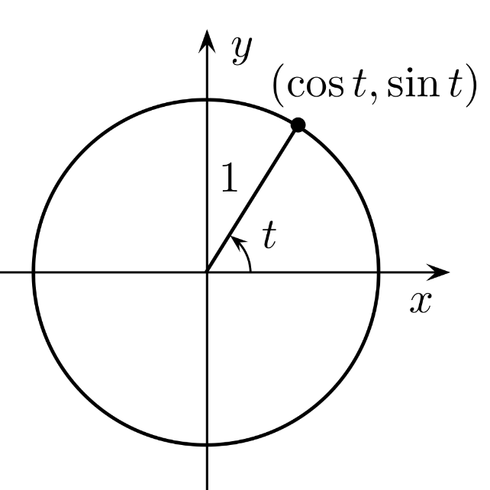

Panning law

Geometry

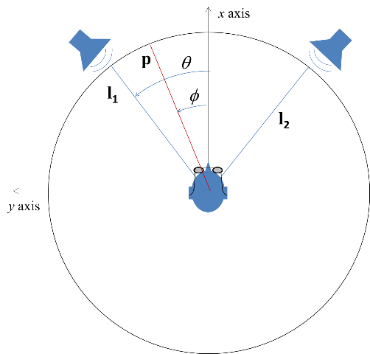

Position of loudspeakers



Virtual position of the source



vector pointing towards source constructed by applying gains to vectors pointing to speakers



You can either multiply this out and solve it as algebra, or do matrix inversion



Lets do the algebra

